727721EUIT066

KAMALESH T

CODING CONTEST:

QUESTION 1:

Give the Name tag of both EC2 instance & keypair as "ec2usecase1"(Name):

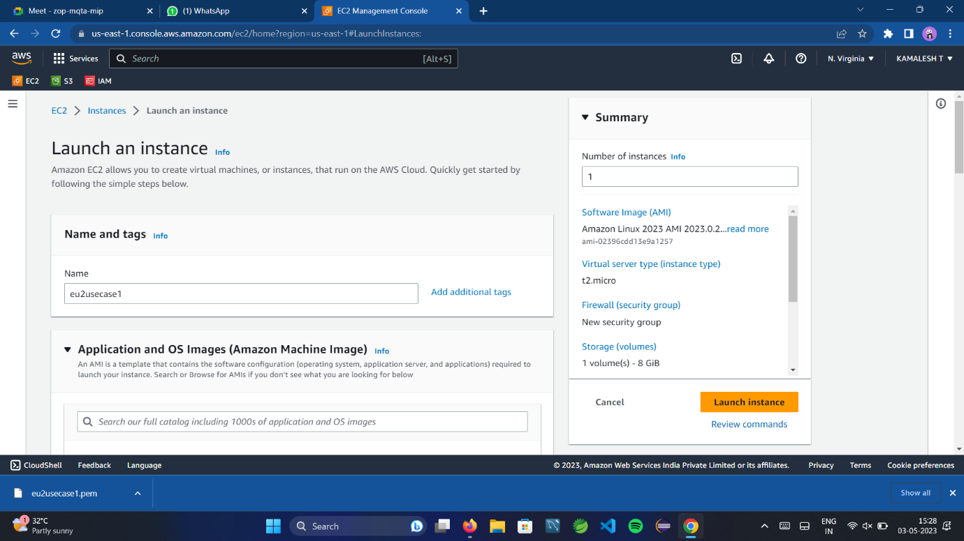

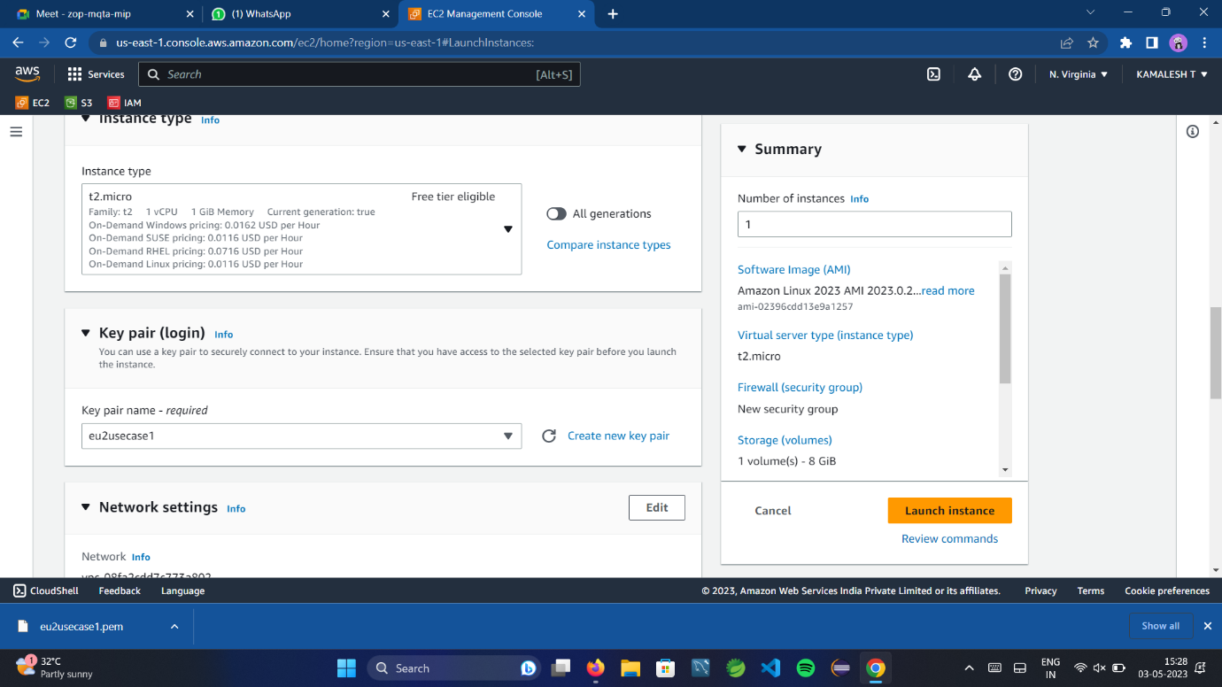

EC2 instance AMI should be "Amazon Linux 2".

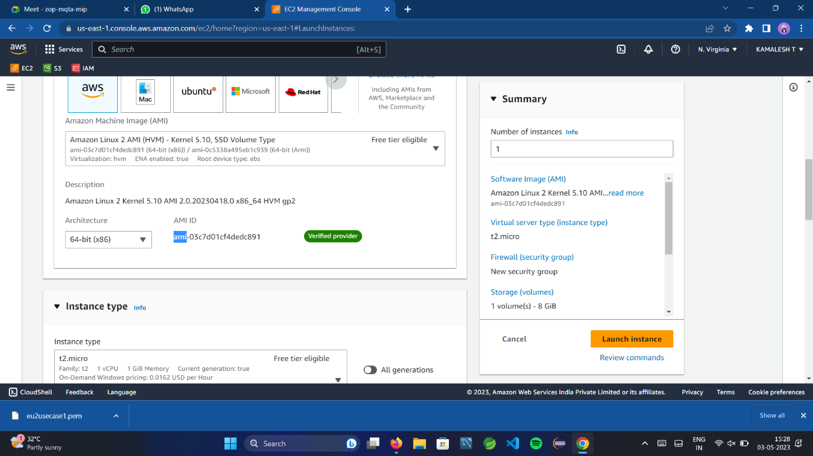

Allow SSH traffic for taking puttyremote connection

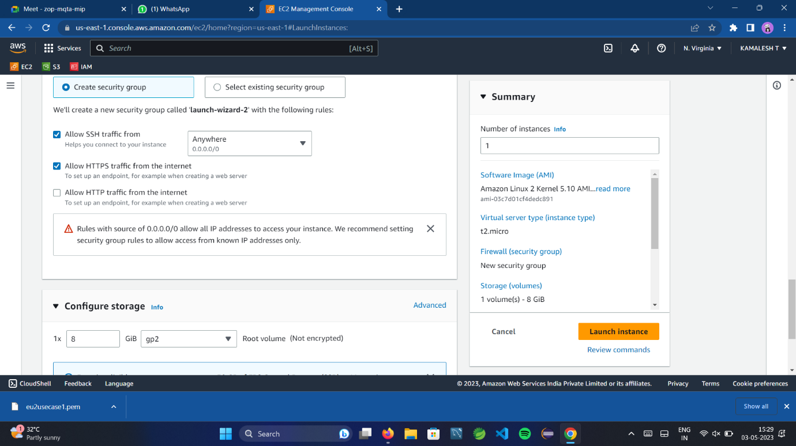

Allow HTTP traffic from the internet for reaching website requests

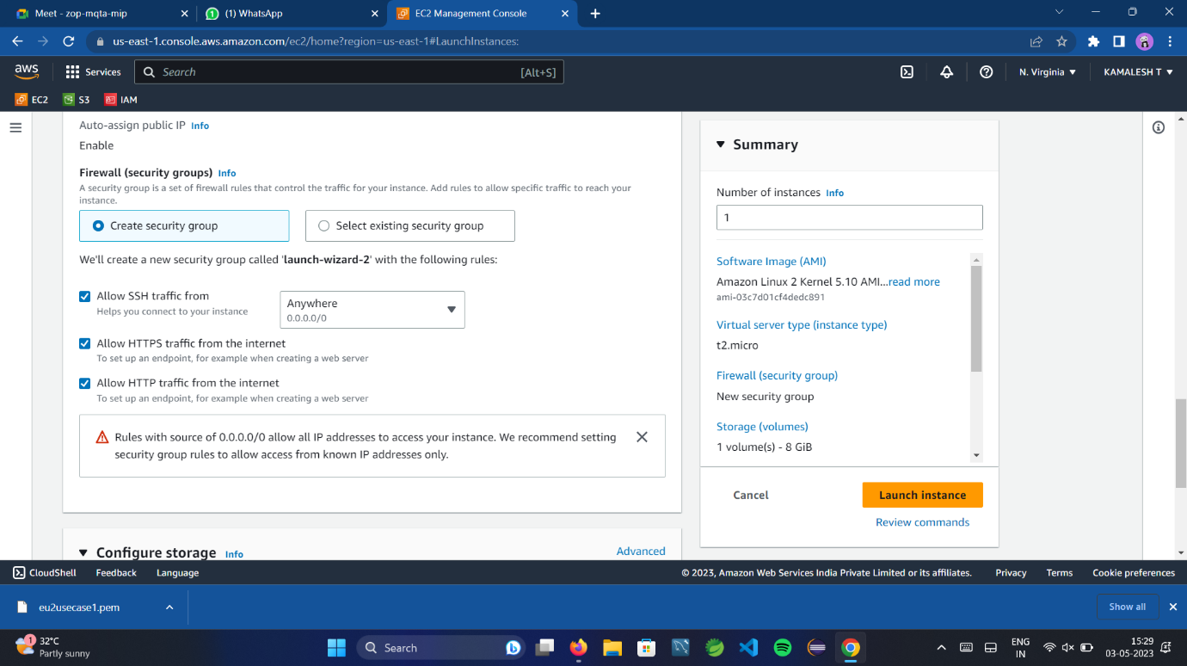

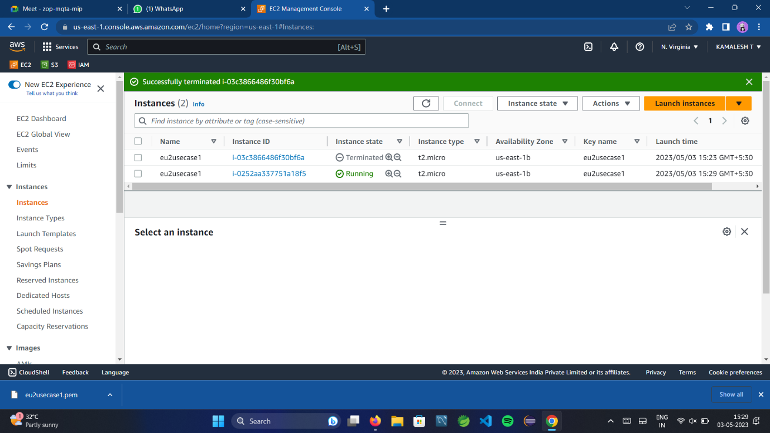

QUESTION 2:

The name of the IAM group should be 'Network-L1-Team'.

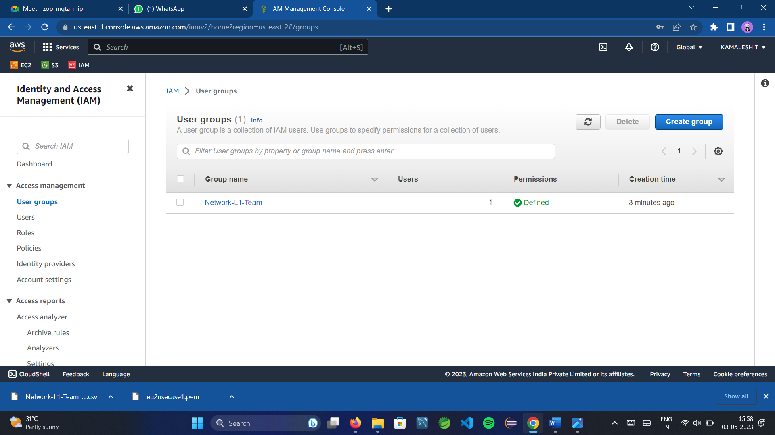

The name of the IAM user should be 'Network-L1-User1'

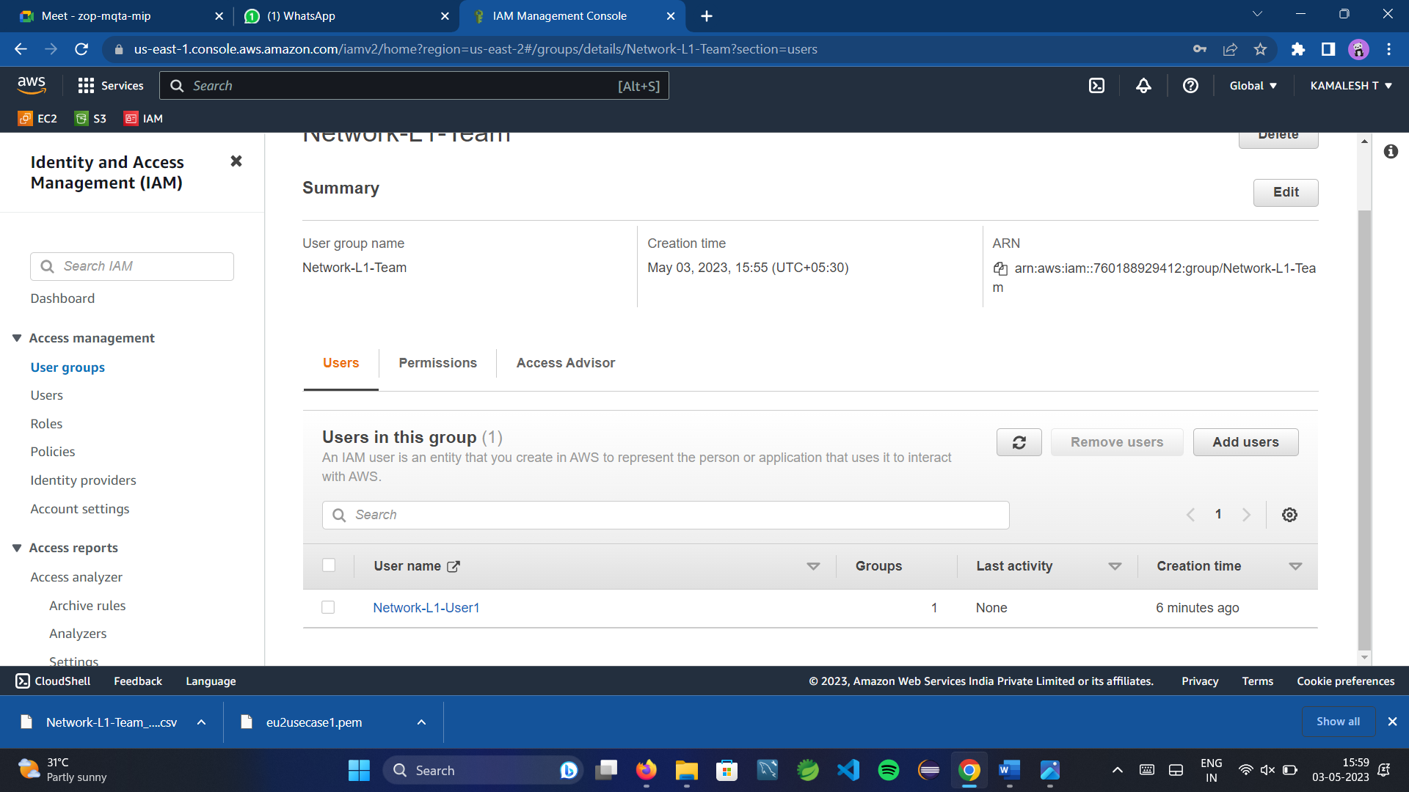

'AmazonVPCReadOnlyAccess' policy should be attached.

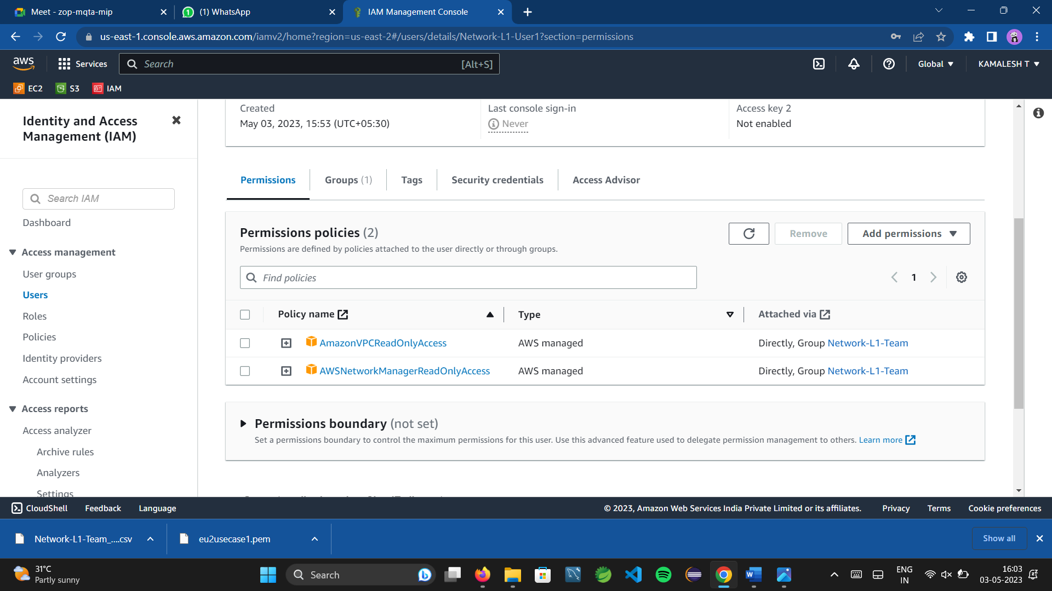

'AWSNetworkManagerReadOnlyAccess' policy should be attached



QUESTION3:

Create a new S3 bucket in the region of "Stockholm"

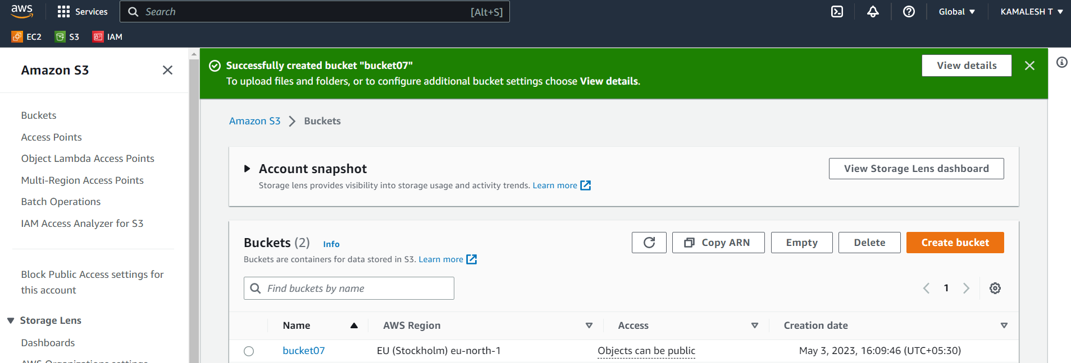

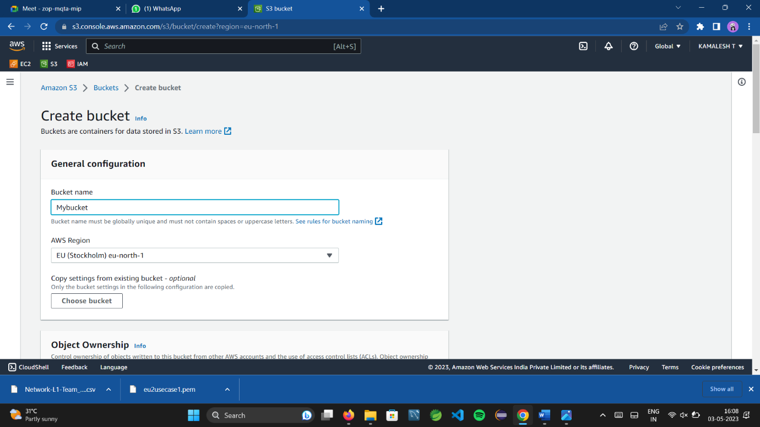

Make the bucket accessible to everyone(publicly) via Bucket ACL

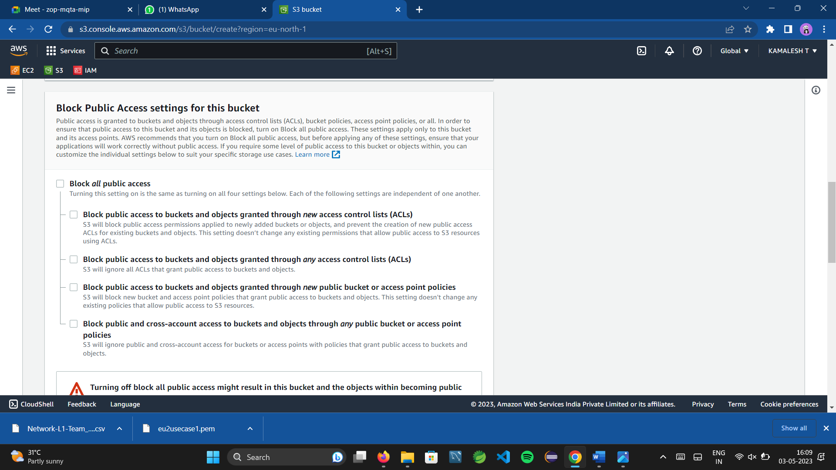

Upload a text file in the name of 'accounts.txt'.

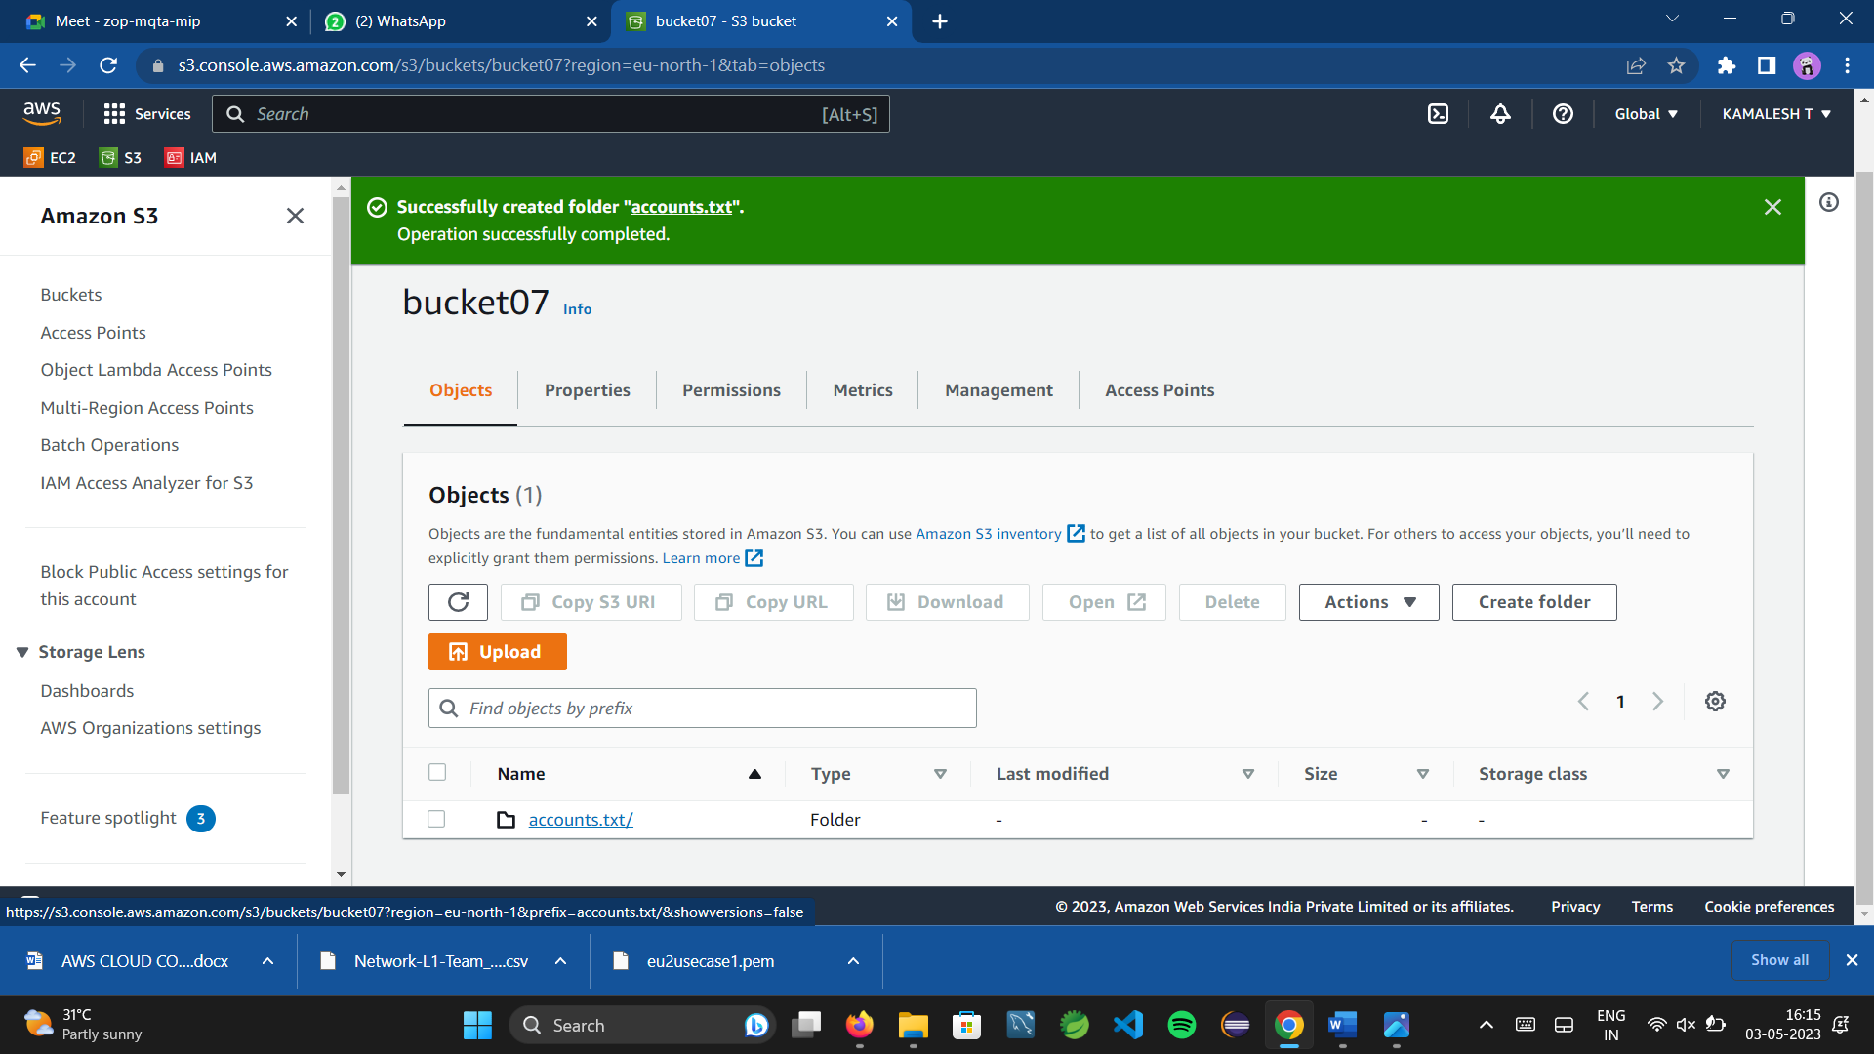

Make the object 'accounts.txt' file accessible to everyone(publicly)

